By Nailah Henry, MPH, Holly Q. Teague, MPH, and Nancy Baum, MHS, PhD

The behavioral health landscape in Michigan
Like much of the nation, Michigan is grappling with a crisis in access to mental health and substance use services (collectively referred to as behavioral health services). This crisis has been growing for many years and was exacerbated during the COVID-19 pandemic. A 2022 report analyzing data from 2019 showed that despite 22% of all Michigan adults experiencing mental illness, nearly half of those (49.4%) did not receive treatment. Additionally, of the 650,000 Michigan adults with substance use disorder, approximately 73% did not receive care. These alarming statistics highlight the scale of the unmet need for behavioral health services, a systemic issue impacting even those with insurance coverage for behavioral health services. Coverage is not translating into access to needed care.
Coverage for behavioral health services in Michigan

Population | Definition | Coverage and payment
Mild-to-moderate mental illness | Symptoms that have a limited to significant impact on daily life | Private insurance  Medicaid Health Plan  Out-of-pocket payments  Medicare Part B
Moderate-to-serious mental illness, substance use disorder, and intellectual or developmental disabilities | Symptoms that substantially limit major life activities | Medicaid “carve out” supports Prepaid Inpatient Health Plans (PIHPs) and Community Mental Health (CMH) service programs

Coverage for behavioral health services
Michigan residents with “mild to moderate” behavioral health (BH) needs have coverage mainly through private insurance or through a Medicaid health plan. People often pay out-of-pocket for outpatient services as many BH providers do not accept insurance.

Individuals with “moderate to serious” mental health needs, those with a substance use disorder, and those with intellectual/developmental disabilities receive services through the public mental health system. A Medicaid “carve out” funds ten Prepaid Inpatient Health Plans (PIHPs) that manage funding for the 46 Community Mental Health (CMHs) programs, as described in the state’s Mental Health Code.

Challenges in the behavioral health system
Managed care plans, including Medicaid health plans, are required to maintain an adequate network of providers—in number and in geographic distribution—with the goal of ensuring patients can receive the BH services they need in a timely manner. Workforce shortages, however, make meeting network adequacy requirements challenging.

About six million Michigan residents live in Mental Health Professional Shortage Areas, and the state would require an estimated 249 more psychiatrists to alleviate these shortage designations. Areas of Northern Lower Michigan and the Upper Peninsula are hard hit by BH provider shortages.

Provider shortages are particularly acute for children: rates of child BH conditions are rising while suicide rates fluctuate. Recent data shows a decrease in suicide rates for people under 25 in Michigan between 2021 and 2022, while other surveys indicate increases in suicidal behavior between 2019 and 2021. Despite this, Michigan has only 11 child and adolescent psychiatrists per 100,000 people, far below the recommended 47 providers per 100,000 people.

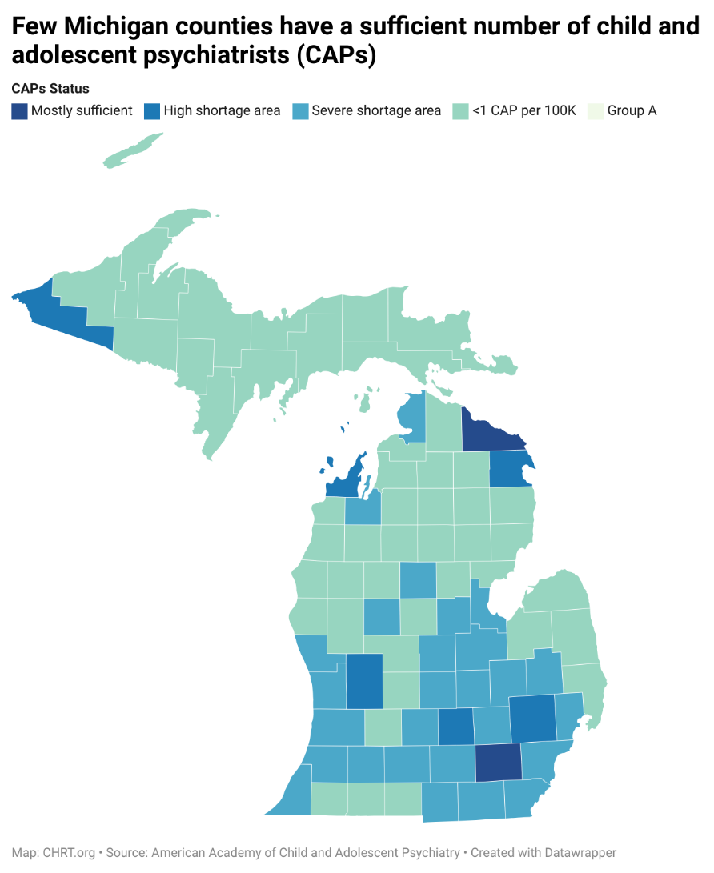
Many of those seeking BH services endure long waits for outpatient appointments and in emergency departments (“ED boarding”). Many community BH providers do not accept insurance and have waitlists for appointments, and too few BH workers are available to conduct evaluations and staff inpatient beds in suitable treatment facilities. A Michigan Health and Hospital Association dashboard reports the number of patients waiting for a BH bed each month. Children and adolescents are particularly impacted by long wait times because of insufficient youth inpatient and outpatient providers, often waiting hours and days for assessment and treatment. Access problems in outpatient settings increase demand for emergency psychiatric care as individuals do not get the care they need in their communities.

Strategies to improve access to behavioral health services in Michigan: Improving access to BH services in Michigan requires taking steps to bolster the BH workforce, ensure adequate insurance coverage, support integrated physical and BH services, and expand community-based and crisis services to reduce demand for emergency services.

  - Workforce: Fund loan repayment for BH providers serving in shortage areas, scholarships for BH education and training, pipeline programs in high schools and colleges, Conrad30 or other visa waiver programs to allow foreign medical graduates to remain, increase residency slots for training psychiatrists
  - Workforce: Support reimbursement for BH telehealth services in Medicaid, Medicare, and private insurance
  - Coverage: Implement and enforce federal mental health parity laws that require equal/no more restrictive coverage for mental health services as for physical health services
  - Physical and BH Integration/Community-Based Services: Support clinical integration of physical and behavioral health care through the expansion of Certified Community Behavioral Health Clinics (CCBHCs), behavioral health homes, and other models of integration
    - Primary care providers diagnose half of all mental illness so efforts to support primary care can also offer significant support for improving access to psychotropic medication and other BH services
    - Evidence-based collaborative care programs like Michigan Child Collaborative Care (MC3) allow psychiatrists to support primary care providers in delivering BH services and are supported through reimbursement by insurers like Blue Cross Blue Shield Michigan
    - In addition to clinical integration, the Section 298 Initiative in 2017 and subsequent efforts have attempted to increase financial integration by designing a path to “carve back in” BH services for the moderate to serious population in Medicaid ,
  - Workforce: Expand scopes of practice for some BH providers, such as nurse practitioners and physician assistants, to allow more providers to practice “at the top of their licenses” to deliver mental health evaluations and treatments.
  - Workforce: Streamline licensure processes to reduce barriers to practice. Interstate licensing compacts allow BH providers to practice and deliver services in neighboring compact states.

References

Nirmita Panchal et al., “The Implications of COVID-19 for Mental Health and Substance Use,” March 20, 2023, https://www.kff.org/mental-health/issue-brief/the-implications-of-covid-19-for-mental-health-and-substance-use/
Corwin Rhyan et al., “Access to Behavioral Health Care in Michigan, 2019 Data Update” (Altarum, December 2022), https://mihealthprod.wpenginepowered.com/wp-content/uploads/2022/12/Health-Fund-2022-Behavior-Health-Access-Study-1.pdf.
Michigan Mental Health Code, Act 258 of 1974. MCL, Chapter 330. https://www.legislature.mi.gov/(S(jwte0ovjycrrg1je0nnkejyu))/mileg.aspx?page=GetObject&objectname=mcl-Act-258-of-1974
Michigan Department of Insurance and Financial Services. “Michigan Network Adequacy Guidance.” Accessed 2/22/24 https://www.michigan.gov/-/media/Project/Websites/difs/Form/Insurance/HMO/Network_Adequacy_Guidance.pdf?rev=1f382232088949be8ac64087a06ac64b
Rural Health Information Hub, “Map of Health Professional Shortage Areas: Mental Health, by County, 2024,” accessed February 19, 2024, https://www.ruralhealthinfo.org/charts/7.
Kaiser Family Foundation, “Mental Health Care Health Professional Shortage Areas (HPSAs),” State Health Facts, November 1, 2023, https://www.kff.org/other/state-indicator/mental-health-care-health-professional-shortage-areas-hpsas/.
Data Resource Center for Child and Adolescent Health, “National Survey of Children’s Health Interactive Data Query (2016 – Present),” National Survey of Children’s Health (2016 - present), accessed February 8, 2024, https://www.childhealthdata.org/browse/survey#52_24_3024; Division for Vital Records & Health Statistics, Michigan Department of Health & Human Services, “1989-2022 Michigan Resident Death Files,” December 8, 2023, https://www.mdch.state.mi.us/osr/cri/Suicide.asp; Centers for Disease Control and Prevention, “Youth Online Data Analysis Tool: High School Youth Risk Behavior Surveillance System - Michigan 2021 and 2019 Results,” April 27, 2023, https://nccd.cdc.gov/Youthonline/App/Results.aspx?LID=MI; American Academy of Child and Adolescent Psychiatry, “Workforce Maps by State,” accessed February 19, 2024, https://www.aacap.org/aacap/Advocacy/Federal_and_State_Initiatives/Workforce_Maps/Home.aspx.
Centers for Medicare and Medicaid Services, “Timely and Effective Care - State,” Provider Data Catalog, January 31, 2024, https://data.cms.gov/provider-data/dataset/apyc-v239.
Michigan Health & Hospital Association, “Behavioral Health - MHA,” https://www.mha.org/, accessed February 19, 2024, https://www.mha.org/issues-advocacy/key-issues/behavioral-health/; Myers and Stauffer LC, “Michigan Inpatient Psychiatric Beds Report (FY2022 Appropriation Act - Public Act 87 of 2021),” July 11, 2022, https://www.michigan.gov/mdhhs/-/media/Project/Websites/mdhhs/Inside-MDHHS/Budget-and-Finance/Legislative-Reports-FY22/07-08-22/Section-1062-PA-87-of-2021.pdf?rev=26f509d8a38c4ca2a1df75e77c87f8d4.
Nancy Baum and Jaque King, “The Behavioral Health Workforce in Rural America: Developing a National Recruitment Strategy,” February 2020. https://chrt.org/publication/rural-americas-shortage-of-behavioral-health-workers/
Kaye Pestaina, “Mental Health Parity at a Crossroads” (Kaiser Family Foundation, August 18, 2022), https://www.kff.org/mental-health/issue-brief/mental-health-parity-at-a-crossroads/.
Angela Beck et al., “Behavioral Health Service Provision by Primary Care Physicians” (University of Michigan School of Public Health Behavioral Health Workforce Center, October 2019), https://www.behavioralhealthworkforce.org/wp-content/uploads/2019/12/Y4-P10-BH-Capacityof-PC-Phys_Full.pdf.
Nancy Baum, “A Primer on Michigan’s Community Mental Health System: A Report for the Ethel and James Flinn Foundation” (Center for Health and Research Transformation, September 2, 2019), https://chrt.org/publication/a-primer-on-michigans-community-mental-health-system-a-report-to-the-ethel-and-james-flinn-foundation/.
Michigan Department of Health and Human Services, “Section 298 Initiative,” accessed February 19, 2024, https://www.michigan.gov/mdhhs/keep-mi-healthy/mentalhealth/section-298-initiative; Senate Staff, “S.B. 597 (S-2) & 598 (S-2): Detailed Summary of Bill Reported from Committee,” November 19, 2021.
Community Mental Health Association, “SB 597 & 598: The Wrong Step At The Wrong Time Dangerous, Costly & Bad for Michigan,” December 2021, https://cmham.org/wp-content/uploads/2021/12/2021-CMHA-Wrong-Step-Dock-v6-1.pdf; Michigan Association of Health Plans, “MAHP Supports Senate Bill 597 and 598, Full Behavioral Health Integration,” Michigan Association of Health Plans (blog), July 16, 2021, https://www.mahp.org/2021/07/16/mahp-supports-senate-bill-597-and-598-full-behavioral-health-integration/.
Mariah Taylor, “8 States Considering Scope of Practice Changes,” Becker Hospital Review, March 10, 2023, https://www.beckershospitalreview.com/hospital-physician-relationships/7-states-considering-scope-of-practice-changes.html.
Felicia Brabec et al., “Michigan Legislature - House Bill 5184 (2023),” Pub. L. No. 5184, HB 5184, accessed February 22, 2024, http://legislature.mi.gov/doc.aspx?2023-HB-5184.

